**Name: Tanuj Dargan Student Number: V01040822**

Instructions: For the below quiz questions show full solutions. You must complete a reasonable attempt for each question. Show your steps.

**Quiz 8 Question 1:** *How would a significant increase in the value of the stock market shift the Aggregate Demand (AD) curve? What effect would this shift have on the equilibrium level of GDP? The price level? Support your answer using a diagram.*

A significant increase in the stock market would shift the Aggregate Demand (AD) curve to the right. This is because higher stock prices lead to increased household wealth, which boosts consumer spending. The rightward shift in AD would result in a higher equilibrium level of GDP and a higher price level.

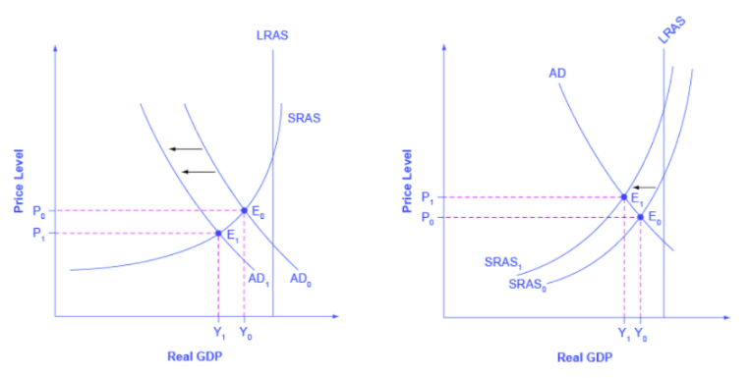

**Quiz 8 Question 9:** *During summer 2020 the Prairie Provinces, which have a large agricultural base, experienced extreme weather with flooding, tornadoes, and hailstorms. This extreme weather reduced the crop yield across the region. Using the AD/AS framework, what is the effect on output, price level, and employment?*

The extreme weather events in the Prairie Provinces during summer 2020, which reduced crop yields, would cause a negative supply shock. This can be represented by a leftward shift in the short-run Aggregate Supply (SRAS) curve. The result would be a decrease in output (GDP), an increase in the price level, and a potential rise in unemployment.

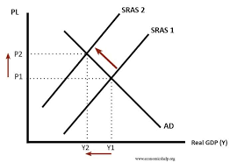

**Quiz 8 Question 11:** *If households begin saving more of their income, what would the impact be on output, employment, and the price level in the short run? Support your answer using a diagram.*

If households begin saving more of their income, it would lead to a decrease in consumption spending. This would cause the Aggregate Demand (AD) curve to shift to the left. In the short run, the leftward shift in AD would result in lower output (GDP), higher unemployment, and a lower price level.

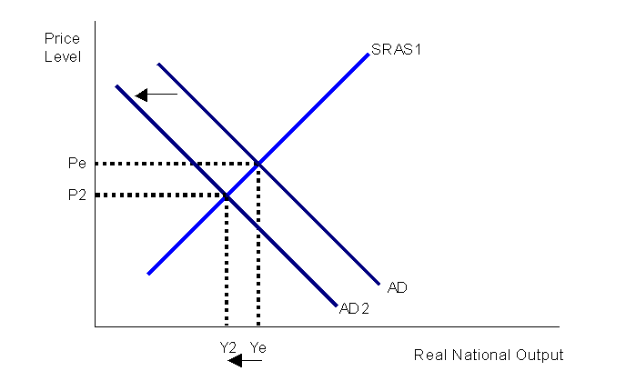

**Extended Reading:**

Please read the third paragraph of the Bank of Canada’s Interest rate announcement on March 6, 2024 (<https://www.bankofcanada.ca/2024/03/fad-press-release-2024-03-06/>) and answer the following questions.

“*In Canada, the economy grew in the fourth quarter by more than expected, although the pace remained weak and below potential. Real GDP expanded by 1% after contracting 0.5% in the third quarter. ①Consumption was up a modest 1%, and final domestic demand contracted with ② a large decline in business investment. ③ A strong increase in exports boosted growth. ④ Employment continues to grow more slowly than the population, and there are now some signs that wage pressures may be easing. Overall, the data point to an economy in modest excess supply.*”

This paragraph discusses the current situation of the Canadian Economy. We will apply the AS-AD model to analyze the important aspects mentioned here.

1. How do ①-④each affect the demand or supply side of the economy? Briefly explain.

① Consumption being up a modest 1% would slightly increase aggregate demand.

② A large decline in business investment would significantly decrease aggregate demand.

③ A strong increase in exports would significantly increase aggregate demand.

④ Slowing employment growth relative to population growth suggests a decrease in aggregate demand. Signs of easing wage pressures could indicate a decrease in aggregate supply.

1. The last sentence states the Bank’s opinion about the current economic situation in Canada. Draw the AS-AD graphs to illustrate the situation in the economy.

The Bank of Canada's assessment of "modest excess supply" suggests that the current level of GDP is slightly below potential, which is consistent with the AD-AS diagram showing a small output gap.

You are welcome to continue to read the entire article if you are interested.